HAMPSHIRE LADIES PLAY AT TWICKENHAM

The Hampshire Ladies team put in strong performances to reach the final of the Gill Burns Division 2 Final at Twickenham with Trojans playing a big part with 10 players in the group matches and nine in the final.

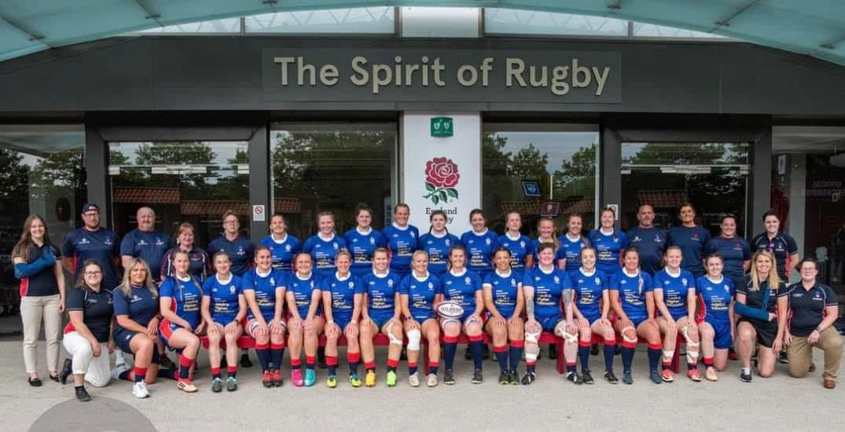

Those players were -
Hannah Kemish (co-captain), Jessica Rudd (co-captain), Clare Brown, Sarah Butler, Becky Fenn, Thea Kilby, Katie Wadeson, Louisa Weinfeld, Chardonnay Wilson and Hannah Wilson, with Abbie Haysom as travelling reserve.

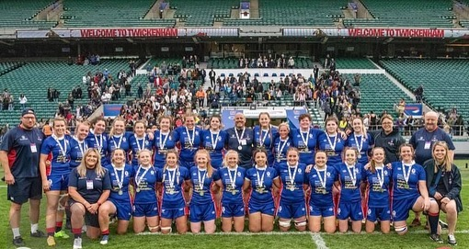

Trojans were also represented on the sidelines in the form of Lead medic: Suzi LeVoi assisted by Charlotte Hussey and assistant coach Donna Rose

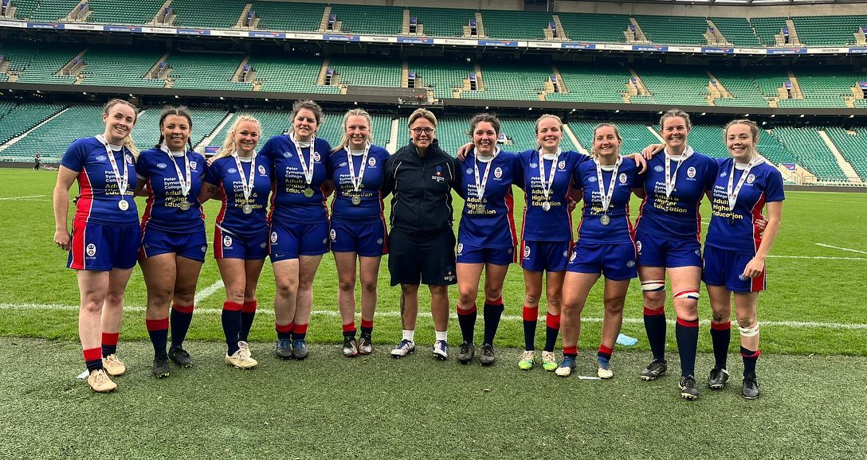

Essex won 48-5
Hertfordshire won 27-12
Devon won 58-5
Eastern Counties lost 19-26

It was said that this game was the best of the four in the day although Hampshire lost by 26 – 19 but the pleasure of playing at Twickenham was apparent despite the loss -

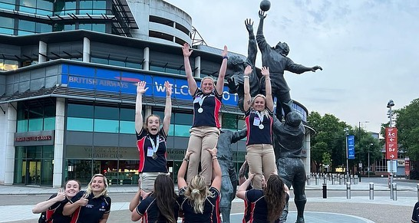

And if Trojans were not represented enough, even one of the two sponsors of the team was Trojan’s past Chairman of Rugby, Duncan Parker of Minuteman press.
