Minutes of the COMMITTEE MEETING of the Section held at the club at 8.00pm on Monday 12th September 2022.

M I N U T E S

Present:-

M Murray
M Ramsdale
T Hall
S Hargrave
M Barnes
W Jones
L Foster
M Coffin
T Thompson

Apologies

S Thomas
C Bolitho
M Windebanke

Agenda

- Updates from individual sections
  - Youth (M Coffin) – 1st two weeks of the new season and numbers OK - some age groups struggling with numbers coaches and looking to recruit players particularly in U13 boys & U8 girls. Will look to upcoming festivals to try and bump up numbers. Every youth coach/manager/first-aider now has an arm band for visible ID as per new RFU guidelines – coaches are yellow, first-aiders are green and managers are orange. A few people have more than one role and for these people it just says on their ID badge.
  - Seniors Men (T Hall) – First 1st XV fixture lost 10-11. Many regulars missing on stag-do – very low backs numbers. Training numbers – Tuesdays very strong (mid 30s), Thursday’s variable with ~10-20. Rudi not coaching on Thursdays – Ed leading sessions which are free-form in the sense the team decides what they should focus on. Discuss if we wanted guest coaches – Rudi brought in some old 1st team regulars over the past few weeks which was well received.
  - Ladies (M Murray) – numbers OK, could be better – won 32-0 in the pre-season friendly against Ellingham Ringwood – 1st league fixtures this weekend (17th Sept)
  - Coaches conference, which was predominantly from the youth section (given number of teams), was held last Friday. It was a great session with considerable interactivity and feedback on what is working well and what could be improved. Huge thanks and special recognition to Wayne Jerimiah who organised and to Tim Dance for doing an awesome job of being the compere (also to Stefan for helping them prepare)
- Finances – end of year accounts shown below:- 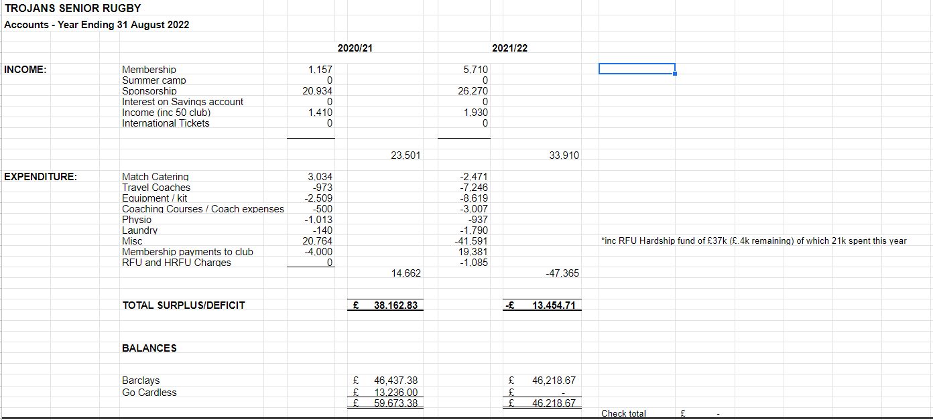
  - Looking at how to reduce catering costs – currently paying VAT at the full rate and don’t believe that should be the case. Looking into this with accountants and could provide £2,000 savings
- Clubhouse update – realistically the full rebuild will require £3M-£3.5M – architects have being presenting proposals to the Trojans board – the club currently has £0.75M. This will be discussed in full at Trojan’s club AGM. The proposed paddle/tennis club will bring in £70K/year through leasing – would need to borrow £2.5M to fund the rebuild. It was noted that 5% interest on £2.5M is £125K – i.e. £70K from paddle club would not be sufficient to cover if interest rates increased. Some members have already voiced concerns over borrowing at the rugby section AGM. Club also investigating what could be done with the money available instead of a full rebuild. Campbell (club chair) has asked Mike Barnes to talk to potential sponsors of the r.e. helping with any building works; Mike has spoken with Reilly’s and Jerry North (metal framework) – intro’s being done and passed onto Campbell. (note that this is not looking for sponsors to cover the work, but to act as trusted partners and operate on a normal contract).
- Meeting rooms – hiring out – Hampshire RFU like using our meeting rooms for the central county location – there is a small incremental cost to us – e.g. heating, lighting etc. New agreement is that any little room linked to club they can use for free (assumed spend in bar covers costs). For larger meetings the main function room can be covered at 50% of usual charge (Hampshire RFU proposed £250 for 5 uses)
- Grounds – Agreement of allocation of grounds costs between the various sections is agin being discussed. Rugby section’s proposal is that we allocate the grounds cost on a per section basis. The total annual cost is ~£75,000 and there is income from renting space for Christmas Party operator, Archery, Boot Camp, AFC Stoneham etc. which provides ~£65,000 – i.e. £10K to find. Proposal that each section is allocated a quota to provide – to be decided at next club board meeting
- Grants – we have been in receipt of the following grants
  - COVID – dispersed
  - Walking rugby
  - Touch rugby
  - All schools program
  - Ladies doing Level 2 qualifications (retrospective application)
  - Student liaison grant (encourage students to play adult rugby)

- AOB
  - (T Hall) – senior men complaining showers far too hot – dangerous for kids, especially those visiting. Mike Murray says there is actually no hot water today. Tony Hall has agreed to investigate and monitor.
  - (W Jones) - Grounds policy discussion – very outdated policy that needs to be re-written and re-published – to be done by Sandra Coffin, Mike Murray, Wyn Jones & Stef Hargrave
  - Lights up at Hardmoor rugby pitches – proposal to erect portable scaffolding plus generator to allow training on these pitches through winter evenings
  - (W Jones) – advised of many rabbits with myxomatosis and there has been a request by a member to assist with a cull using an air rifle. Committee members voiced concerns over safety and we will work to see what is possible
  - (T Thompson) - concerns about glasses near pitches – remind bar staff to ask people and offer plastic glasses – also get a sign – both actions taken by Mike Murray
  - (M Ramsdale) – recent changes in player eligibility through the “gender participation policy” – M Ramsdale & M Murray to review policy and understand what impacts this will have with any current Trojans’ players.
  - (M Coffin) - post protectors out for girls rugby - ask groundsman to lift them while cutting to avoid damaging them
  - (M Coffin) - Appreciation to groundsman (Dave) on E II R logo in memory of the Queen on grass outside of the club house
  - (M Coffin) – Appreciation to the kitchen staff for the pasta after 1st XV game on Saturday – many positive comments
  - (M Barnes) – Sponsorship update – currently running about £20K-£21K/year (actual numbers dependant on timing).
  - (M Barnes) - Sponsors lunch Oct 15th – numbers currently low – committee members to encourage attendance
  - (L Foster) – FirstSports significant errors with membership fee collection over the summer – missed some direct debits, over-charged some, incorrect administrative “suspension” of players. Lee working closely with them to manage and should be resolved by early October
  - (L Foster) - Mistakes being made in GMS regarding Youths picking student membership – should improve through clearer choices when we switch to new website.
  - (S Hargrave) – RFU accidentally deleted all of our allocation of International tickets and, as a gesture of goodwill, provided 10 tickets to NZ game. Allocation has increased slightly - 6 Nations now 39 tickets. Also provided 54 tickets for the 2022 Autumn Internationals (due to price these are now more difficult to sell) – S Hargrave proposed that any unsold Autumn International tickets should be given to members who have significantly helped the club – this was agreed
  - (S Hargrave) - We will use the International ticket allocation as publicity to join Trojans
  - (M Barnes) – No “Mike’s Balls” as was done prior week
  - (M Ramsdale) – website update – email will be sent to all members on how to hide their personal phone numbers on the new website. New website to be live from Sunday 18th September.

M Ramsdale
Hon. Secretary
12th Sep 2022

~~~~~~~~~~~~~~~~~~~~~~~~~~~~~~~~~~~~~~~~~~~~~~~~~~~~~~~~~~~~~~~~~~~~~~~~~~~~~~

