Minutes of the COMMITTEE MEETING of the Section held virtually at 8.00pm on Monday 6th December 2021.

M I N U T E S

Present:-

M Murray
T Thompson
M Ramsdale
T Hall
S Hargrave
P Reid
W Jones
M Coffin

Apologies

M Windebanke
M Barnes

Agenda

1. Actions
2. Finances - some failed direct debits Lee Foster to advise
3. Update from Youth and Seniors
- Ladies - both teams 3rd in table. Promotion still possible, but not in our hands. London Irish training 3x week and having advanced medical help. Two full teams out regularly with replacements
- Mens - Struggling with numbers. No second team last week. Extensive injuries. Good start to 2022 will keep us up, 2 more wins mid table. Inconsistent team composition. Concern that coach, Neal, will become disillusioned.
- Youth - Numbers are high. Waiting list for U6s & U7s. Youth teams are still having new players arriving. Some concern from other clubs that we are stealing players, chairman receives complaints, Marcus Coffin maintains that is not the case. Academy have 7 players in County – Hampshire U18 recently lost to Sussex. 4 of last year’s academy regularly playing senior (although still eligible to play Academy under Covid rules until January 2022)

4. Mike's magic balls
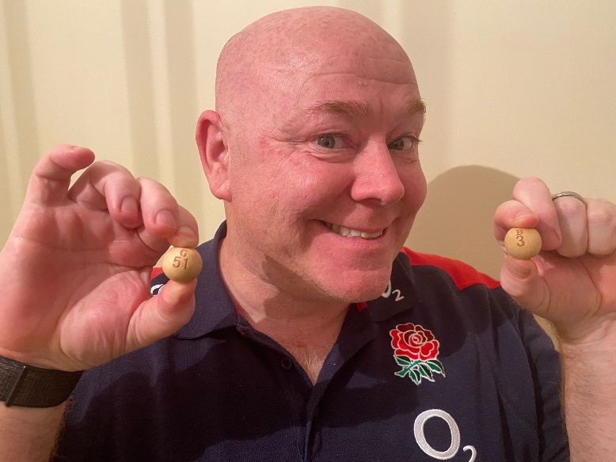
Here are Mikes Magic Balls. Nos 3 and 51 who are R Starr and R Colenso both winning £50 each

5. Trojans Club Board update - ongoing discussions r.e. redevelopment of clubhouse
- More rugby representation needed on board. Tony Hall asking why board do not advertise widely - there are 3 rugby board members and secretary are from rugby. Should we hold an election to nominate a director from rugby?
- Board thankful for rugby’s membership donation. Hockey have withheld some money due to disagreement over cricket and rugby receiving more club funds for grounds maintenance - they want a fairer method of repayment.
- Squash have capped membership due to recently closed David Lloyd courts.

6. AOB

What's happened this month:

Go Cardless
Update info from Irwin Mitchell, new steps to take and try before we engage them. No real updates from

Hardmoor
Fencing up and gate in and ready to be used - youth age groups moving across this Sunday. There is also a rugby pitch between 2 football pitches. Football tenancy to be evaluated in Spring. Pitch could be used for training. Can they be used by men without nets near motorway

Rugby Safe Lead
RSL is a group that are taking a lead on regulation 9 relating to the safety of players. Whole bunch of new regs coming in September. Sandra is club RSL and liaising with Suzi for seniors. A gap analysis is being performed ot the new regs to see what we need to progress. Google sheet which is updated and the link has been provided to authority. RSL and club physio to decide future requirements as all teams need pitch side first aiders for all games.

Safeguarding Update
One safeguarding case remains open - RFU have read and responded.

One racism complaint. First instance been dealt with between clubs otherwise via citing.

International Tickets
6 nations money coming in.

Membership
Great work from Tony, Mike and Sandra and we have transferred over £35k to the club. (previous years £28k), but can I please ask you to keep pushing as we need members to be signed up as it's quite frankly not fair on those who are paying.

Diversity Officer
MW and I have discussed this role and MW has made contact with the Hampshire lead, verbal update in meeting.

Hardship Fund
We have £20k and this is how it's currently being spent:
- £1200 for ground breaking in November (requested by Wyn and Dave). This will include the cricket outfield
- £2500 for our share of half for the fencing at hardmoor
- £6k for the fencing at the bottom by the lake - at clubs request
- £2.5k for post protectors on all pitches as current ones not the safest
- £6,800 machinery for groundsman in response to the ground report received from Sport England/RFU

This totals £19k of the £20k we had available to spend (we had already spent £10k in previous financial year). On basis the above figures have an approximation about them, waiting until all paid before looking to spend remainder.

Tony Hall said electric fault in kitchen - need to appoint cert. electrician (Jack Rowlands?). Likely need new warming cupboard. Extra from hardship.

Grants role
Richard Sparkes has agreed to be our point of contact for grant applications. This will be done in the background and he'll keep plugging away as they come up to see what we can get! Richard won’t be on the committee.

Walking Rugby
Lee Foster looking at setting this up. Start in late spring for better weather.

Operational issues
Bar manager and club manager disagreeing – being handled by facilities manager. Wyn Jones suggests rugby committee support bar manager

End of season dinner and awards
Agreed date of Friday 8th April. Adults, no partners. Pete Reid to provide list of awards.

Friday Night Lights
Trojans cancelled Friday under the lights game 10th Dec due to availability because of 2 fixtures on Saturday. Will reschedule for the next free weekend on Friday 4th Feb.

Seniors coaching
Tony Hall to discuss action plan with coaches.

Ties for 200 & 300 caps
Should provide special ties for 200 caps and 300 caps - need to submit a design. Need to clear with other sections as it’s a club decision. Also look retrospectively who have done it and invite them to end of season dinner.

Hats
Ordered another 200 OddBalls bobble hats.

M Ramsdale
Hon. Secretary
7th Dec 2021

~~~~~~~~~~~~~~~~~~~~~~~~~~~~~~~~~~~~~~~~~~~~~~~~~~~~~~~~~~~~~~~~~~~~~~~~~~~~~~

